|  |  |  |  |
| --- | --- | --- | --- |
| **TITLE:** | AR-03 Check the load in Transflo(back up) | | |
| **sop #:** | QAG-23 | **revision #:** | 1 |
| **EFFECTIVE DATE:** |  | | |
| **OWNER:** | Ravinder Saini | | |

## REVIEWERS

|  |  |  |  |
| --- | --- | --- | --- |
| Name | tITLE | sIGNATURE | dATE |
| Martin Schmidt | Senior Analyst, Solutions Design |  |  |

## APPROVER

|  |  |  |  |
| --- | --- | --- | --- |
| Name | tITLE | sIGNATURE | dATE |
| Ravinder Saini | QRA Manager |  |  |

# 1.0 purpose

Look up documentation received for each load

# 2.0 SCOPE

Covers process to lookup loads in Transflo.

# 3.0 equipment

N/A

# 4.0 definitions

|  |  |
| --- | --- |
| **Definition** | **Explanation** |
|  |  |
|  |  |
|  |  |
|  |  |
|  |  |

# 5.0 Responsibility

|  |  |
| --- | --- |
| **Responsibility** | **Activity** |
|  |  |

# 6.0 policy

## 6.1 GENERAL

1. Open the Transflo system
2. Select INTTRIPS and enter in the load number in the field (LOADNO) and click search.

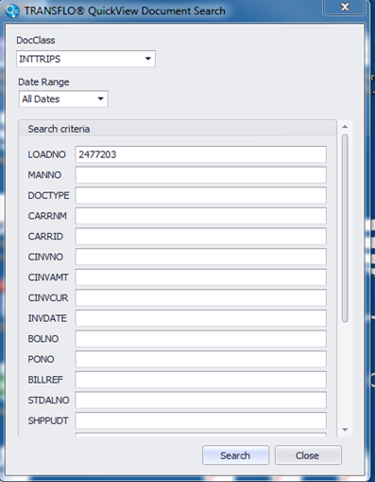

1. All documents types (back up) will appear as seen below.

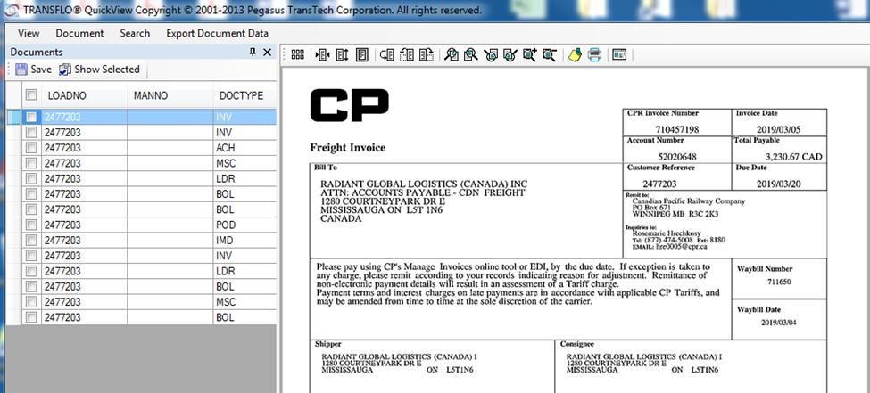

1. Select the document you are looking for and either print, save or email it.

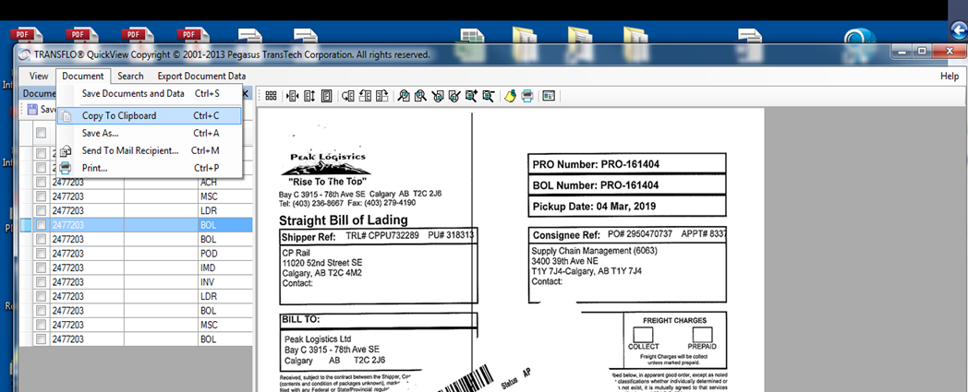

# 7.0 references

# 8.0 revision history

|  |  |  |
| --- | --- | --- |
| **Revision #** | **Revision Date** | **Description** |
|  |  |  |